Micro-Controller:

Bootloader installation and operation

Ver 1.0

2019/03/05

Author: Marshall Colville

Email: [mjc449@cornell.edu](mailto:mjc449@cornell.edu)

Copyright (c) 2019, Marshall Colville

All rights reserved.

This documentation, relevant source code and hardware designs are released under the FreeBSD

Redistribution and use in source and binary forms, with or without modification, are permitted provided that the following conditions are met:

1. Redistributions of product specifications, source code, and documentation must retain the above copyright notice, this list of conditions and the following disclaimer.

2. Redistributions in binary form must reproduce the above copyright notice, this list of conditions and the following disclaimer in the documentation and/or other materials provided with the distribution.

THIS PRODUCT IS PROVIDED BY THE COPYRIGHT HOLDERS AND CONTRIBUTORS "AS IS" AND ANY EXPRESS OR IMPLIED WARRANTIES, INCLUDING, BUT NOT LIMITED TO, THE IMPLIED WARRANTIES OF MERCHANTABILITY AND FITNESS FOR A PARTICULAR PURPOSE ARE DISCLAIMED. IN NO EVENT SHALL THE COPYRIGHT OWNER OR CONTRIBUTORS BE LIABLE FOR ANY DIRECT, INDIRECT, INCIDENTAL, SPECIAL, EXEMPLARY, OR CONSEQUENTIAL DAMAGES (INCLUDING, BUT NOT LIMITED TO, PROCUREMENT OF SUBSTITUTE GOODS OR SERVICES; LOSS OF USE, DATA, OR PROFITS; OR BUSINESS INTERRUPTION) HOWEVER CAUSED AND ON ANY THEORY OF LIABILITY, WHETHER IN CONTRACT, STRICT LIABILITY, OR TORT (INCLUDING NEGLIGENCE OR OTHERWISE) ARISING IN ANY WAY OUT OF THE USE OF THIS SOFTWARE, EVEN IF ADVISED OF THE POSSIBILITY OF SUCH DAMAGE.

The views and conclusions contained in the hardware, software, and documentation are those of the authors and should not be interpreted as representing official policies, either expressed or implied, of the Micro-Controller project, Paszek or Zipfel Labs or Cornell University.

Contents

Abbreviations 4

Introduction 5

Hardware 6

External connections 6

Internal connections 7

Bootloader Installation 9

Prerequisites 9

Precautions: 9

From a pre-built binary 10

Connect the Programmer 10

Installing the bootloader 11

From source code 14

Connect the Programmer 14

Building the bootloader 14

# Abbreviations

|  |  |
| --- | --- |
| Abbreviation | Name |
| I/O | Input/output |
| HID | Human interface device |
| ICSP | In-circuit serial programming |
| MLA | Microchip Libraries for Applications |
| PCB | Printed circuit board |
| UC | microcontroller |
| USB | Universal serial bus |
| ANx | Analog output x |
| DIx | Digital input x |
| DOx | Digital output x |
| GND | Ground / VDD |
| DCx | Bipolar analog output x |
| FNx | Function/waveform generator output x |
| IPE | Integrated Programming Environment |
| IDE | Integrated Development Environment |

# Introduction

The Micro-Controller Project is an open-source solution for hardware control and synchronization of scientific instruments. The focus of the project is to provide a general-purpose platform for integrating multiple peripheral devices in custom optical microscopes, enabling rapid prototyping and development of new tools and techniques. The hardware portions of the project are designed to be flexible and generic to increase the range of applications and portability of the device.

The hardware, software, and firmware are released under the permissive FreeBSD License to encourage contributions from users and developers, expanding upon the expertise and applications of the project’s originators. The bootloader source code was derived from the Microchip® USB HID bootloader included in the MLA and is licensed under the Apache License, v2.0 (http://www.apache.org/licenses/LICENSE-2.0). Source code, design files, and documentation are hosted online at <https://github.com/mjc449/SAIMscannerV3.git>. For the latest documentation and source files please visit the project repository.

This manual covers the USB HID bootloader portions of the project. The bootloader is a small piece of code that resides below the application firmware. On a device reset the bootloader will either enter programming mode or direct execution to the application firmware. Typically, reprogramming the microcontroller is done via ICSP with a dedicated hardware programmer. Reprogramming via ICSP requires the user to open the controller enclosure, connect the programmer hardware and place the device in programming mode via a switch on the PCB. In programming mode, the bootloader can rewrite the flash memory segments reserved for application code. The updated firmware is received from the host system over the USB connection, providing a convenient update mechanism that eliminates the additional hardware and physical access to the PCB required for ICSP.

# Hardware

## External connections

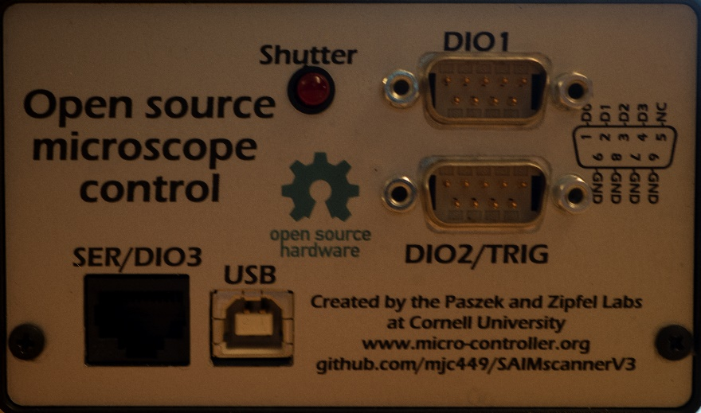

SER/DIO3 – Reconfigurable serial port (SPI, UART) or digital I/O. The function of the port is set in the application firmware and can be changed programmatically at runtime.

USB – USB full-speed type B connection to host

DIO1 – Digital I/O port 1. Reconfigurable at runtime as inputs or outputs

DIO2/TRIG - Digital I/O port 2. D2-D3 are reconfigurable as hardware interrupt sources in application firmware and can be changed programmatically at runtime to switch between interrupt and general purpose I/O.

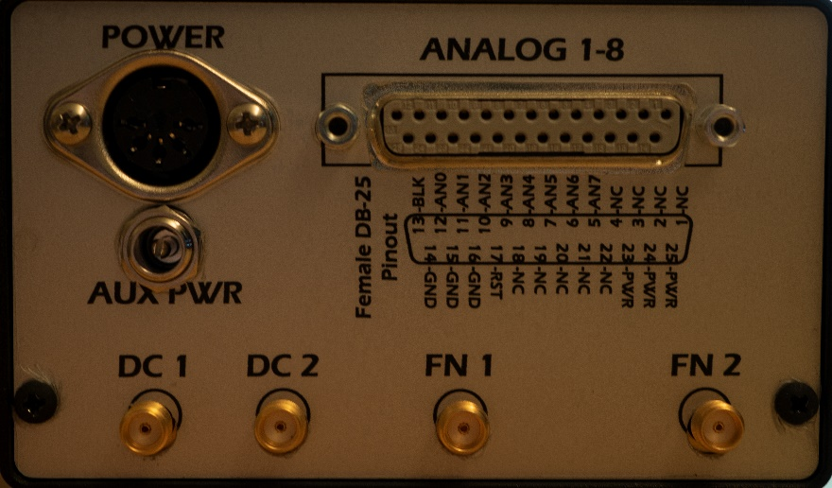

POWER – Five-pin 180° DIN power jack. Pinout going counter-clockwise from left: +5V, +12V, GND, -12V, GND

AUX PWR – Power supply pass-through to pins 23, 24, 25 on DB-25 connector.

ANALOG1-8 – 8 Channel analog output (0-10V) with 10V digital blank, ground and power.

DC1, DC2 – Bipolar analog outputs

FN1, FN2 – Function generator outputs

## Internal connections

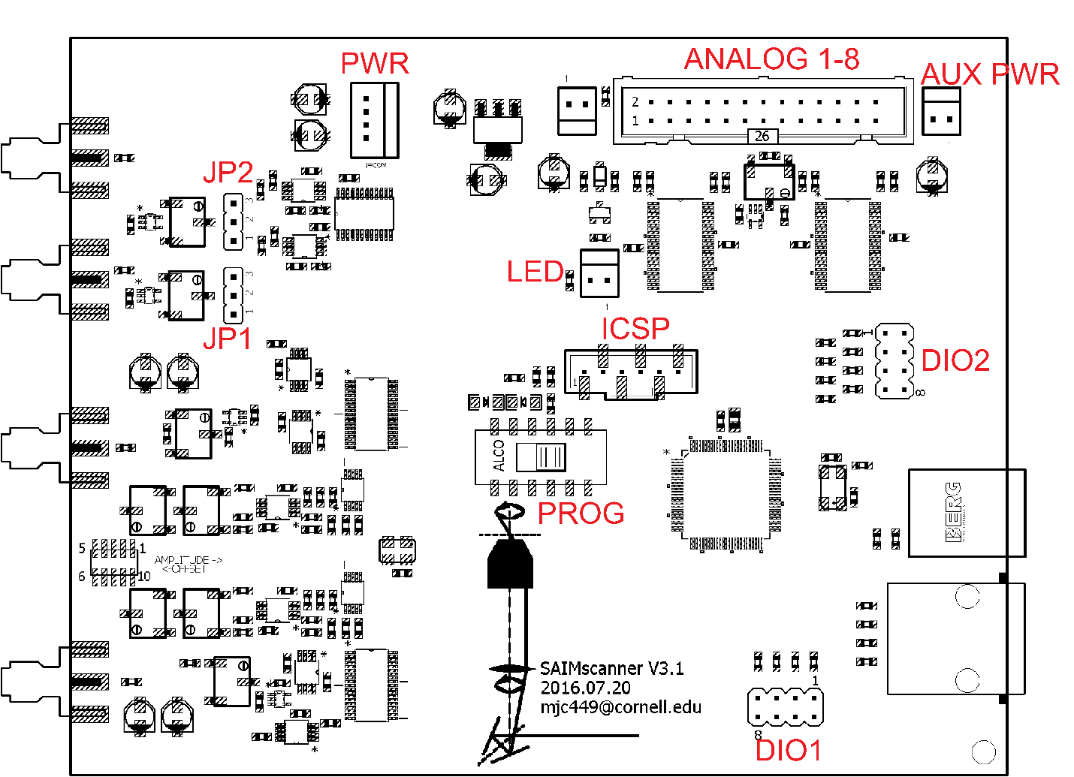

PWR – Power connector

1. GND
2. -12 V
3. +12 V
4. +5 V

JP1/JP2 – DC output reference selection. Jump pin 1 to 2 for 10 V fixed reference or 2 to 3 for 0-10 V settable through the trim pot.

ANALOG 1-8 – Multiplex +10V analog outputs.

NC 1, 3, 5, 7, 10, 12, 14, 16, 18, 26

GND 2, 4, 6

AUX PWR 20, 22, 24

+5 V RESET 8

+10 V BLANK 25

ANALOG 1-8 9, 11, 13, 15, 17, 19, 21, 23

AUX PWR – External power supply passthrough to ANALOG connector.

LED – Front panel LED, connected to ANALOG +10 V BLANK pin.

DIO1/DIO2 – digital I/O headers.

PROG – slide switch to select between ICSP program mode and application run mode. In program mode the red LED is on. In run mode the red LED is off and the green LED is on. Also used to place the device in bootloader mode.

ICSP – Serial programming port. With the PROG switch in run mode all pins are NC. The following functions are available in run mode.

1. MCLEAR – active low master clear
2. VDD - +3.3 V logic level
3. VSS – Digital ground level
4. PGED – serial data
5. PGEC – serial clock line

# Bootloader Installation

## Prerequisites

The bootloader must be programmed into the controller via ICSP before application code can be programmed over USB. In the case of a new controller that has not had the bootloader installed, a corrupted installation or upgrades to the bootloader firmware the following tools will be required:

1. A compatible serial programmer. This manual assumes a PICkit4 available from Microchip is being used. Alternatives exist, however it is up to the user to determine how to install the bootloader if other hardware is being used.
2. The Microchip Libraries for Applications available for free download from <https://www.microchip.com/mplab/microchip-libraries-for-applications>
3. Microchip MPLAB IPE available for free download from <https://www.microchip.com/mplab/mplab-integrated-programming-environment>

The following components are only required for building the bootloader from source code. Development and customization of the bootloader requires only the compiler, however this manual uses the MPLAB X IDE in the examples and does not cover command-line compilation. These components are not required for installing a pre-build binary.

1. Microchip’s MPLAB X IDE available for free download from <https://www.microchip.com/mplab/mplab-x-ide>
2. Microchip’s XC16 C Compiler available for free download from <https://www.microchip.com/mplab/compilers>

### Precautions:

* Opening the enclosure exposes the PCB. To prevent damage from static discharge do not remove the PCB from the enclosure base.
* Handle the unit by the enclosure base.
* Unplug the power supply and disconnect any peripherals before opening the enclosure.
* Take care not to touch or allow anything conductive to contact the ICSP header when the controller is in program mode (red LED illuminated), as this can damage or destroy the controller.

## From a pre-built binary

### Connect the Programmer

1. Remove all connections to the micro-controller unit.
2. Remove the two phillips head screws from the front of the micro-controller, freeing the front panel from the enclosure.
3. Gently pull the front panel outward and downward from the rest of the enclosure.
4. With the ribbon cables and wires clear, slide the enclosure top free of the base and set aside
5. Disconnect the 25 conductor ribbon cable from the header on the PCB assembly.
6. Remove jumpers from the the ICSP port (if present)
7. Connect the programmer to the ICSP header. Pin 1 on the header should correspond to the arrow on the programmer inline socket.
8. Slide the program switch to the program position (toward the ICSP port).
9. Connect the power supply to the controller, ensuring the red program LED is illuminated.

### Installing the bootloader

1. With the programmer connected and the controller powered in program mode, launch MPLAB X IPE

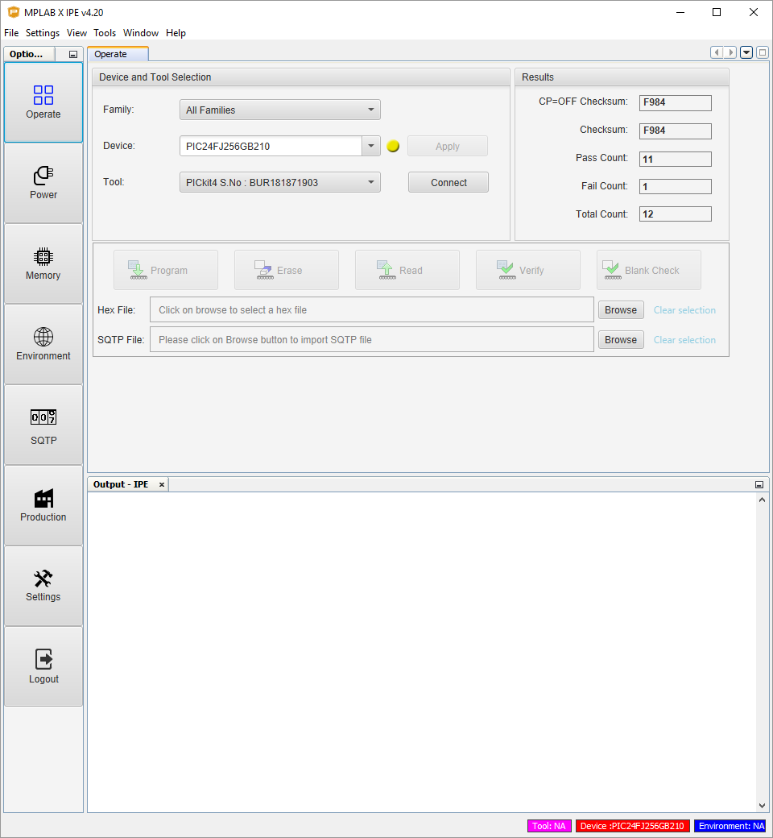

1. In Device and Tool Selection select “16-bit MCUs (PIC24)” for Family, “PIC24FJ256GB210” from Device, and PICkit4 S.No : XXXXXXXX” from Tool, where XXXXXXX is the serial number of the programmer.

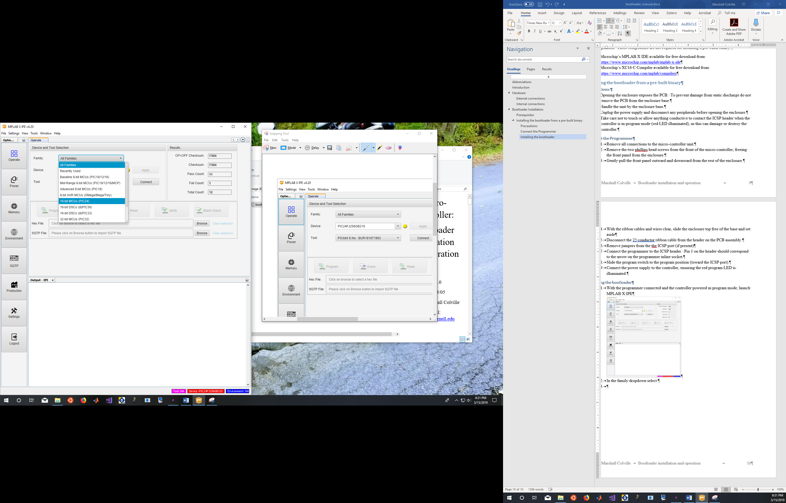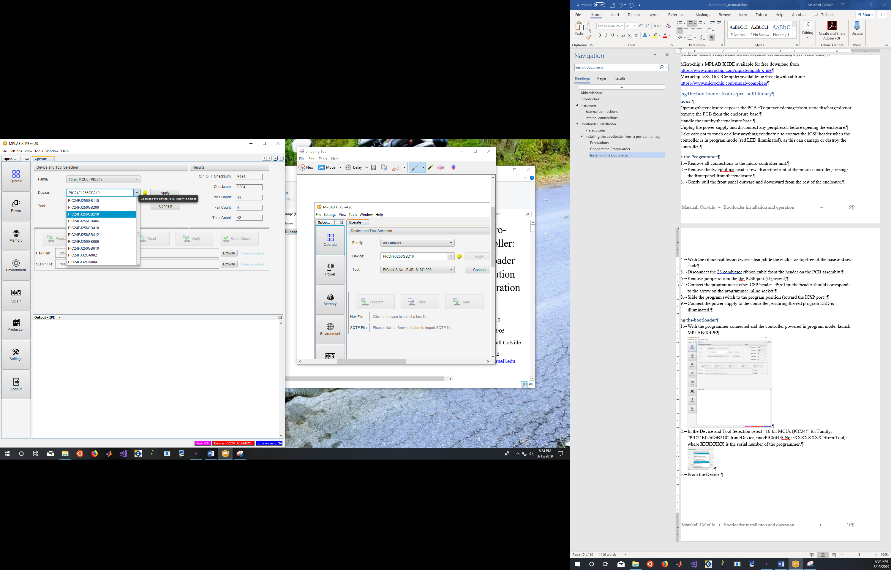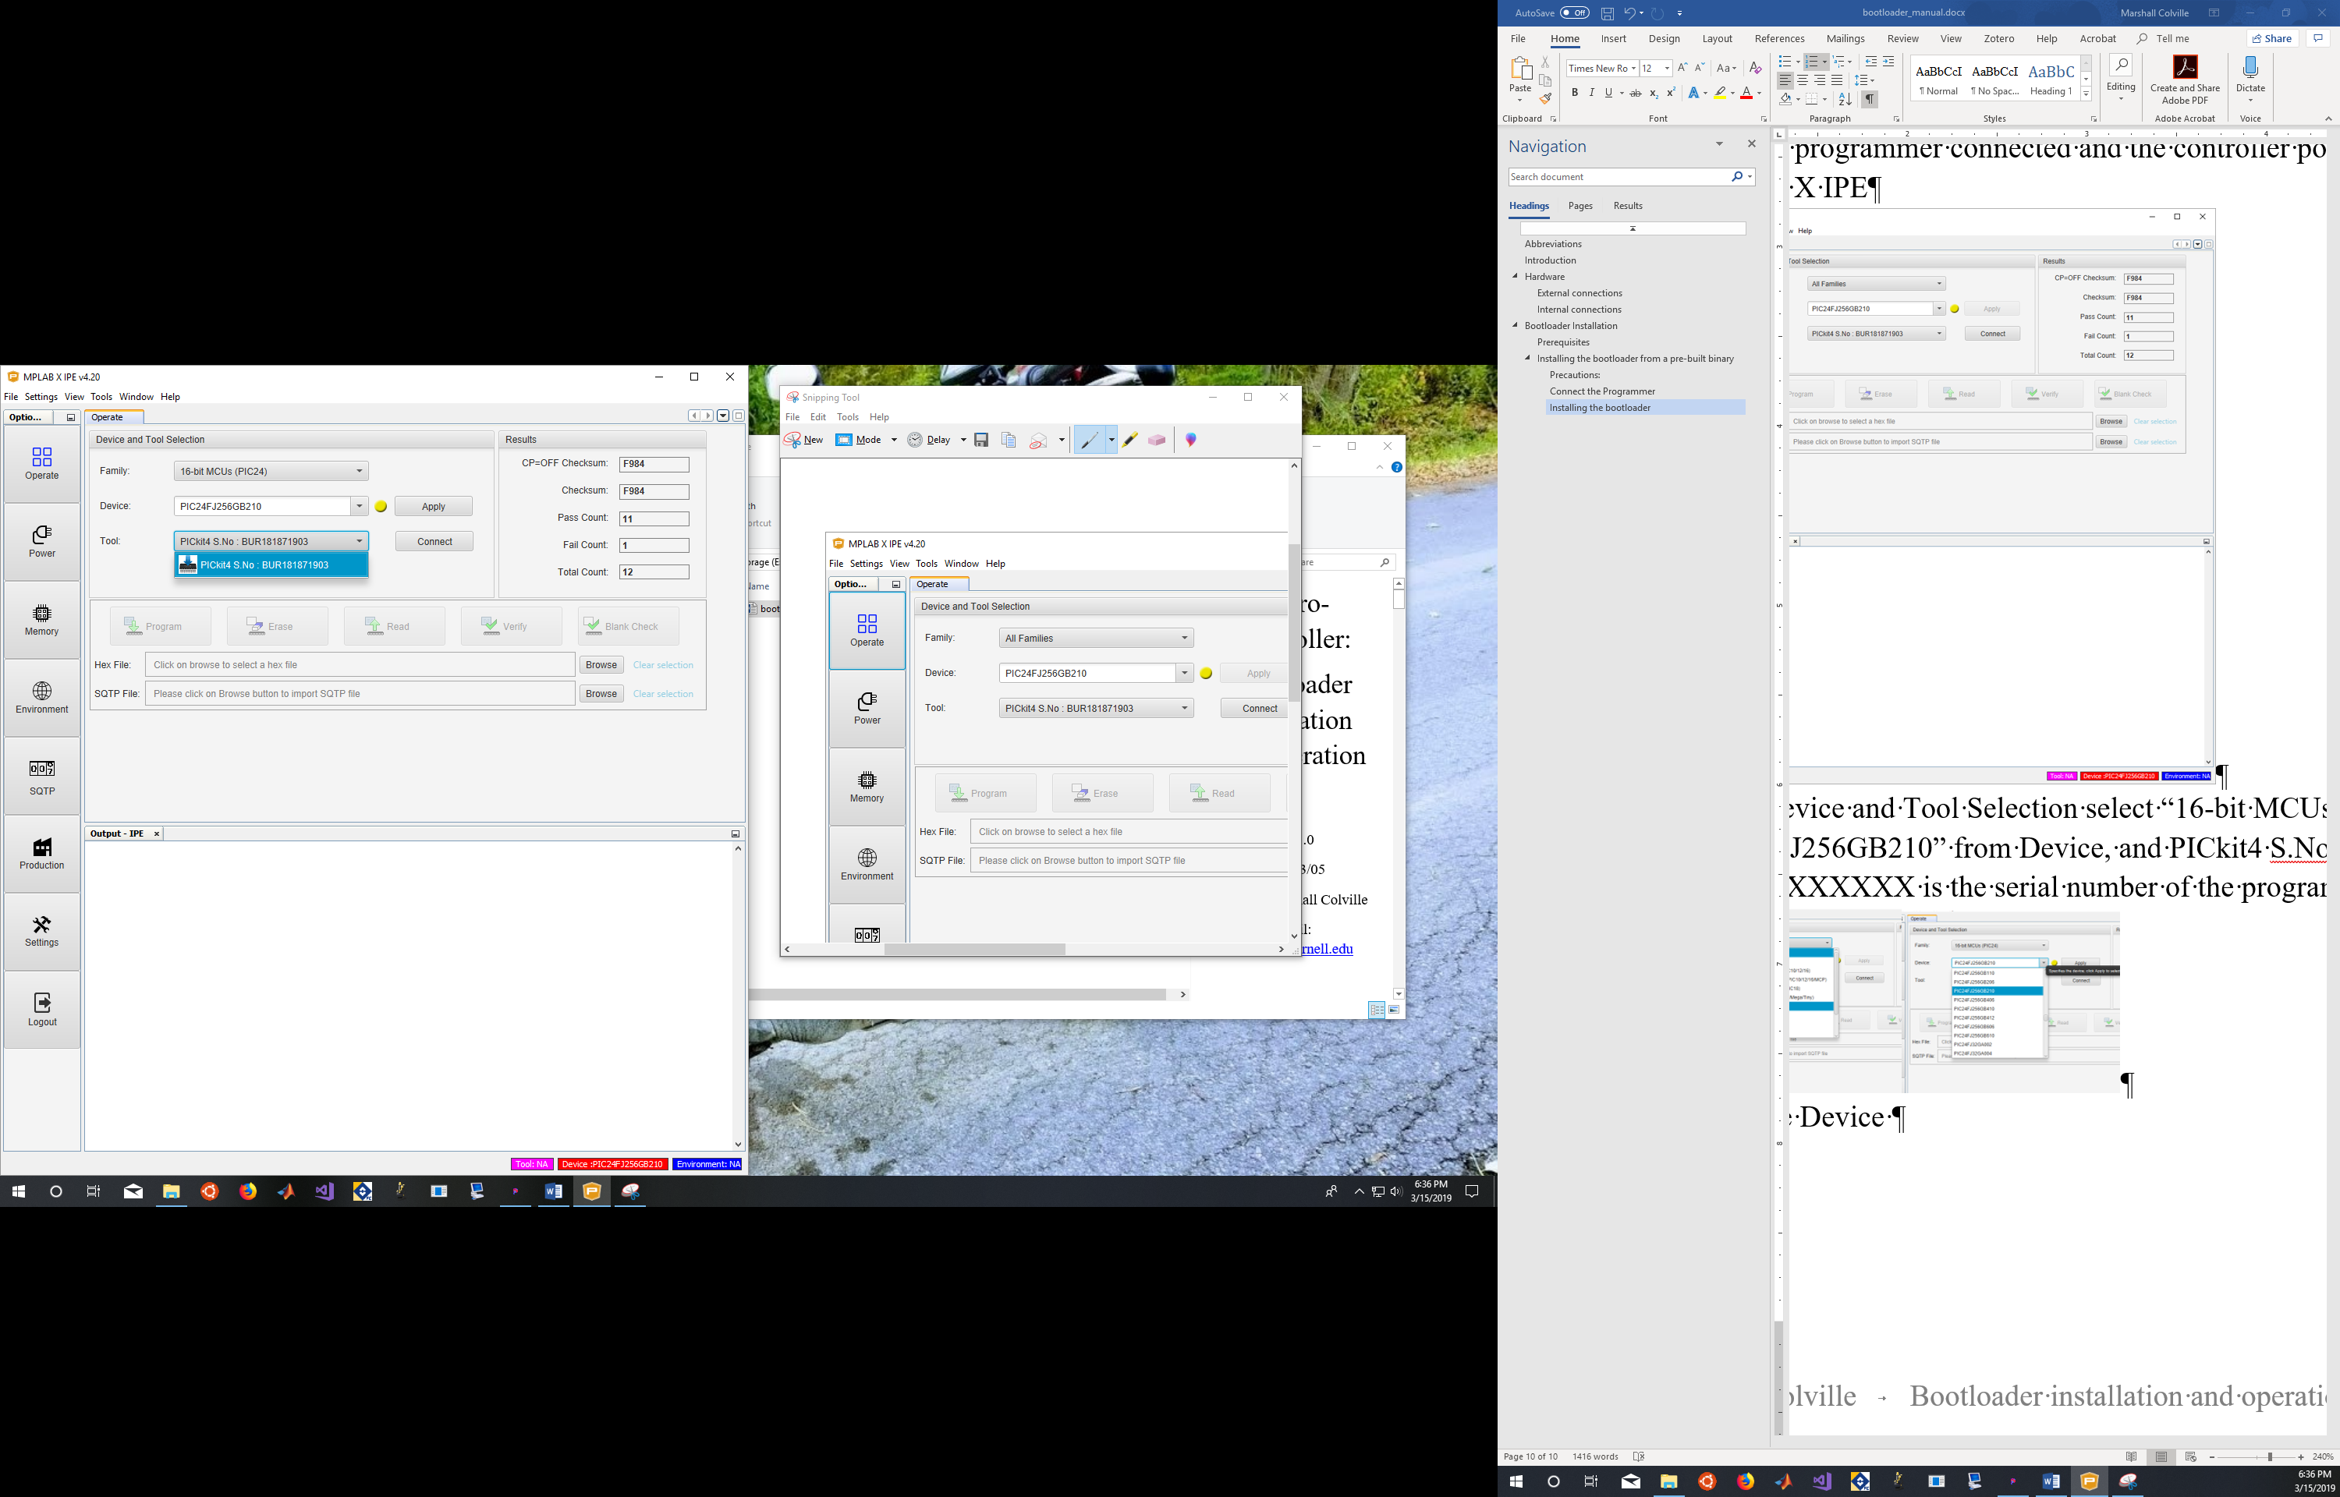

1. From the toolbar select “Settings>Advanced mode”. An options toolbar will appear to the left of the window. Select “Power” and check that VDD is set to 3.25 V and “Power Target circuit from Toll” is not selected.

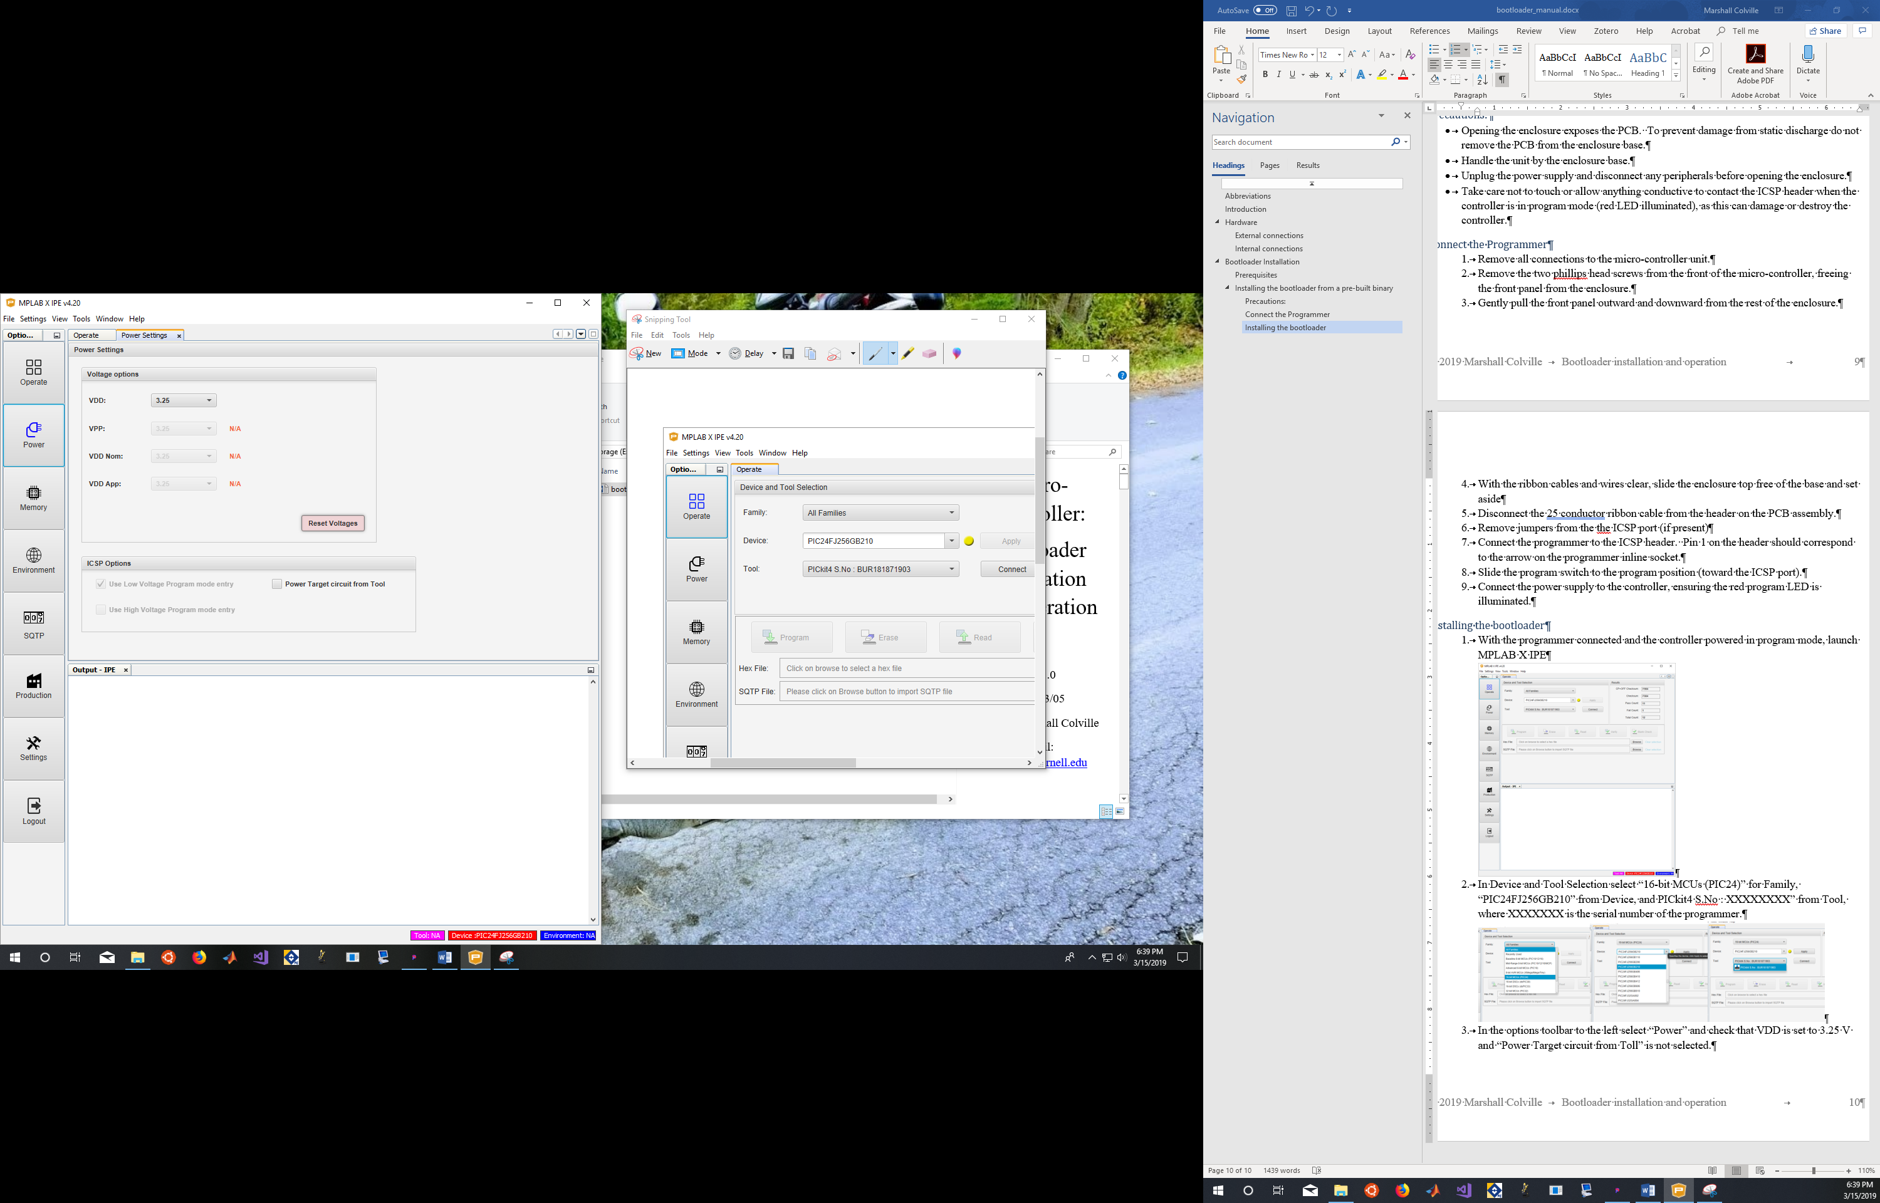

1. On the Operate tab click “Connect”. The device information will be printed to the output window. The specific output may vary depending on the tool and version, however ensure that “Target voltage detected” and “Target device PIC24FJ256GB210 found.” are present.

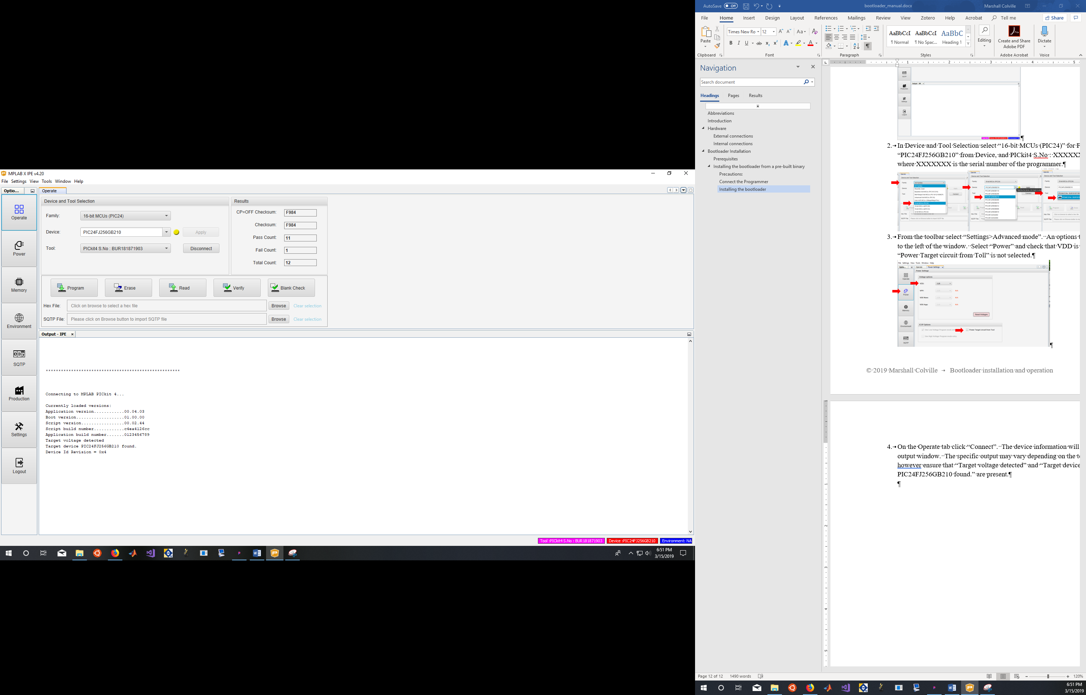

1. Select “Browse” or enter the path to the bootloader Hex file. The pre-built hex file can be found in the project repository at: SAIMscannerV3\firmware\bin\mc_bootloader.X.production.hex

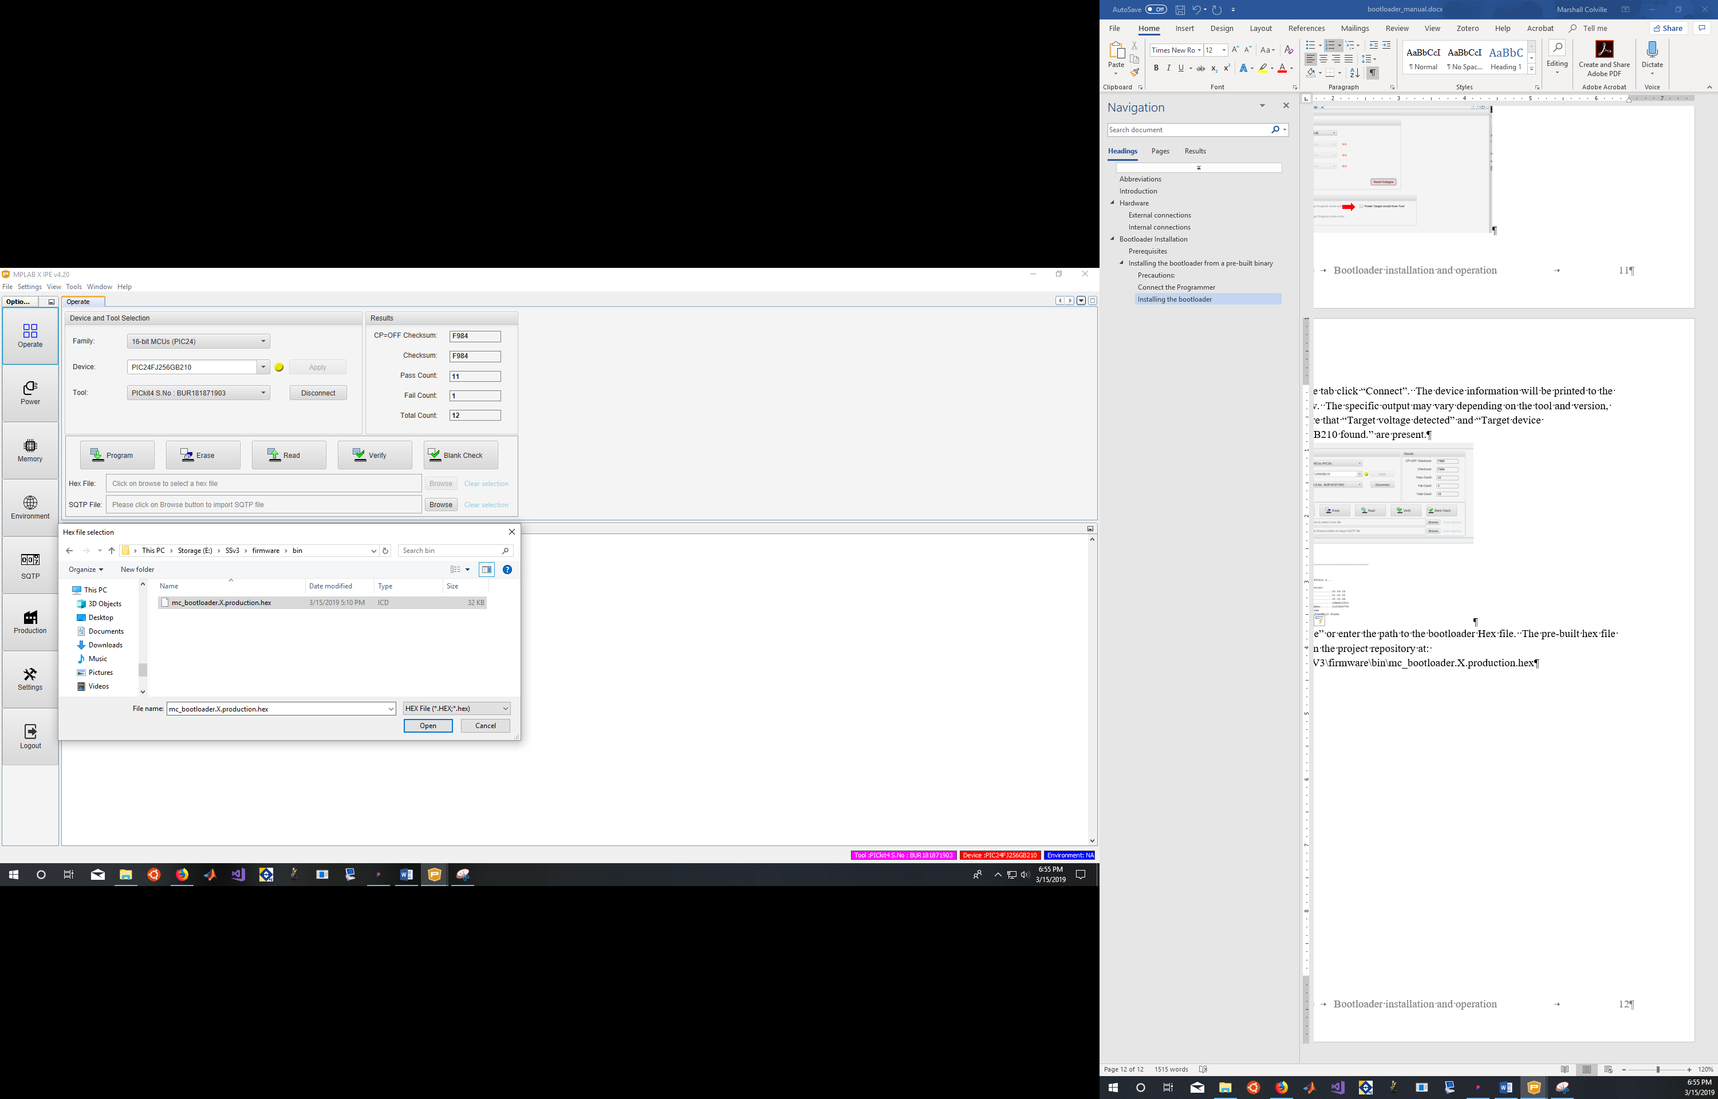

1. Check the output window to make sure the file loaded correctly. If so there will be a line of blue text ending in “ – Hex file loaded successfully.” Once the file is loaded click “Program”

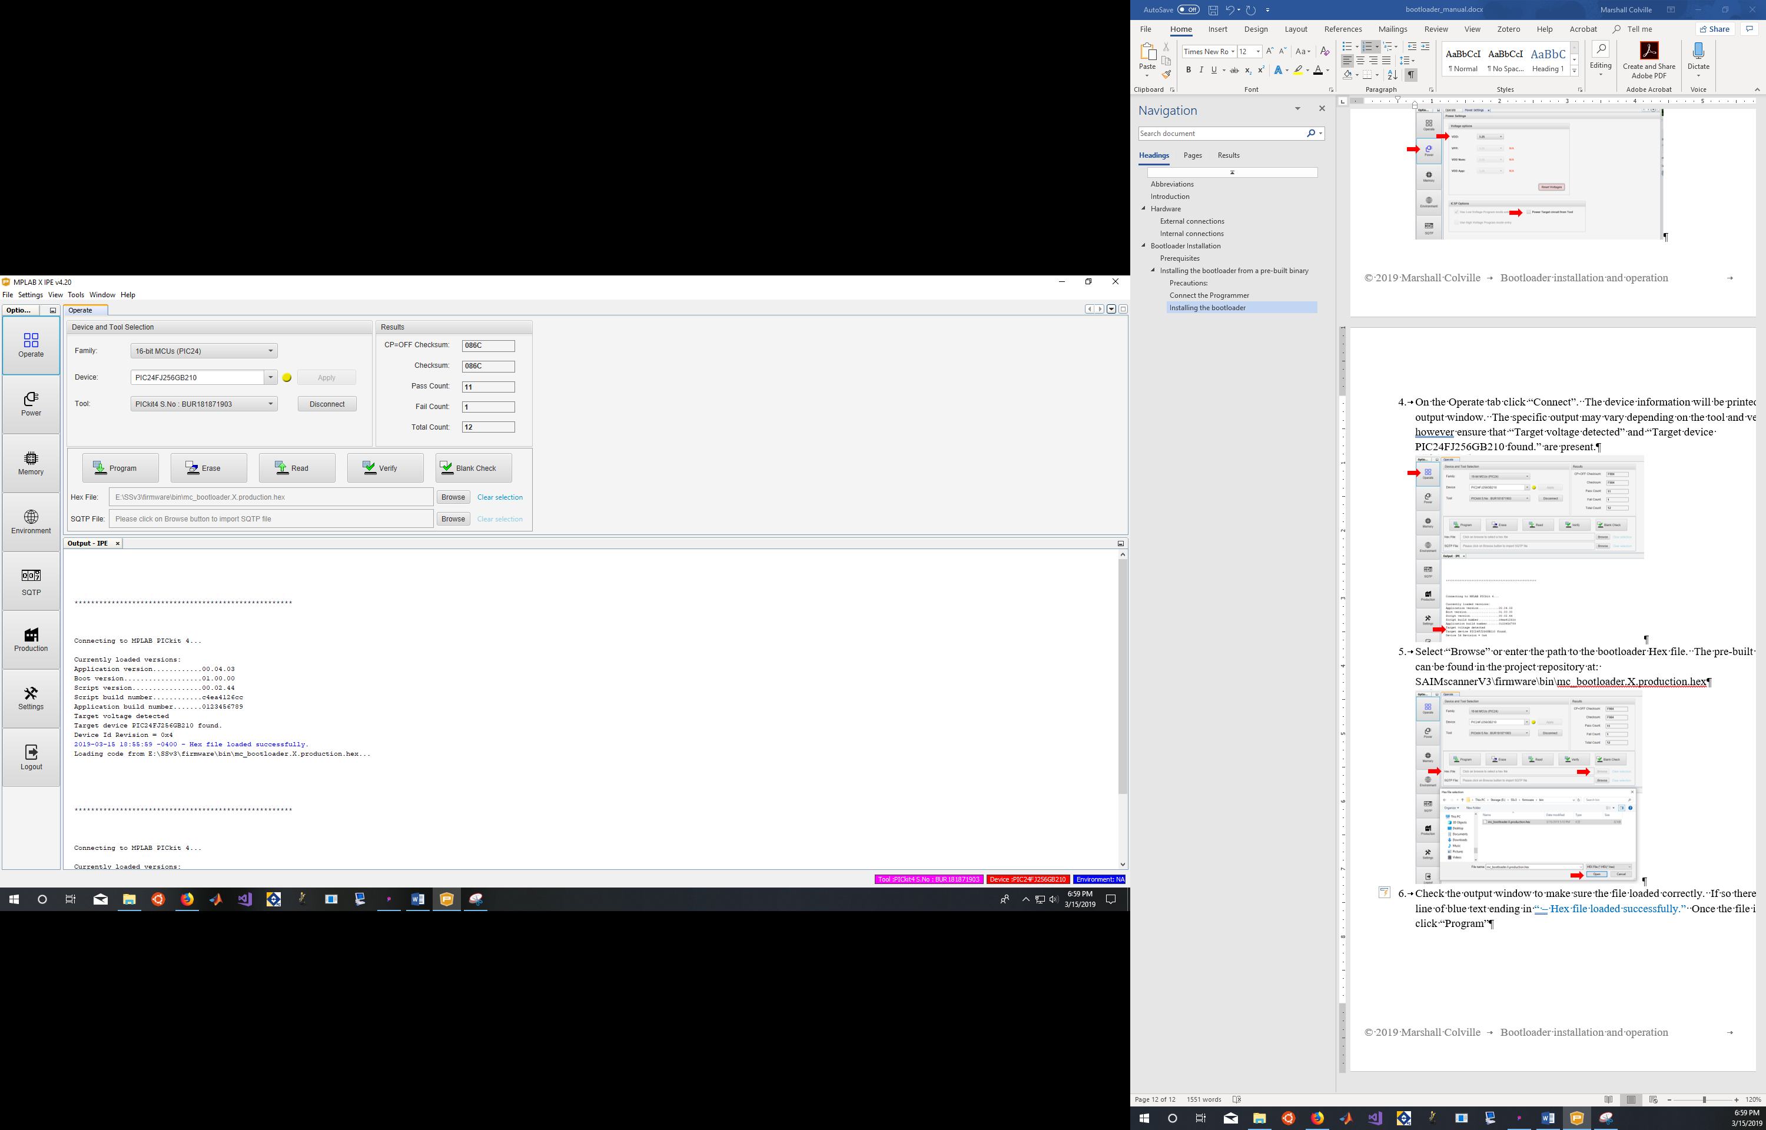

1. Once programming has finished check the output window. There should be a block of text at the bottom that ends in a line of blue text stating “- Programming complete”.

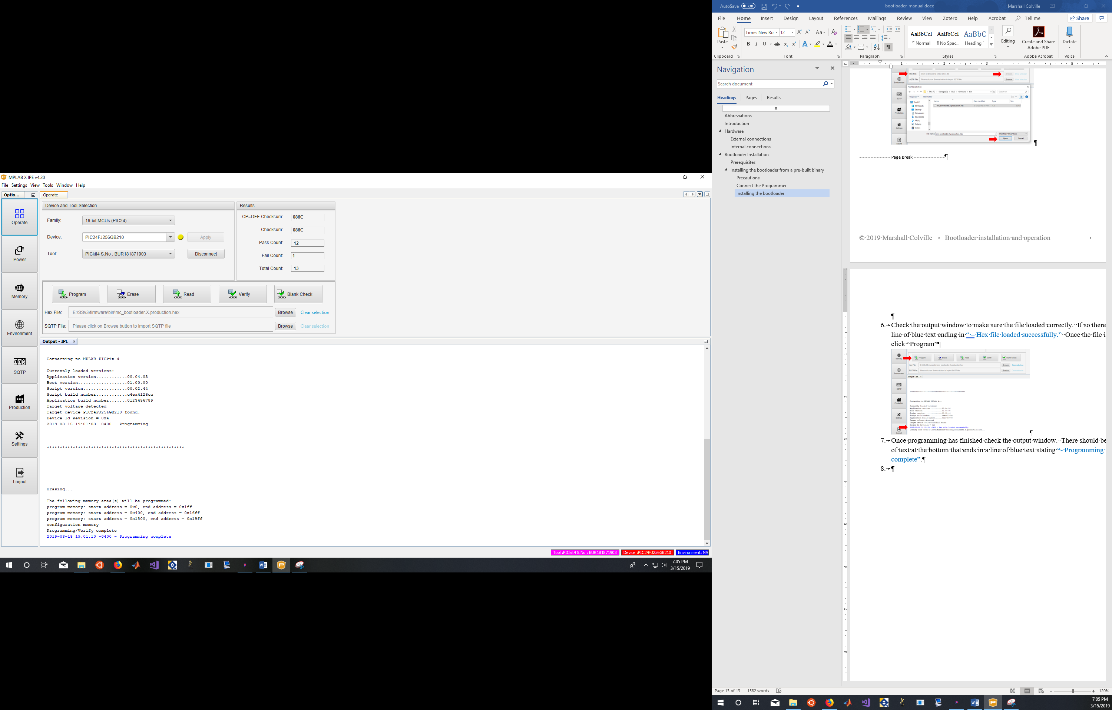

1. Click “Disconnect”, the unplug the programmer from the board, disconnect the power supply and return the programming switch to the run position.
2. Reassembling the controller in the enclosure is the reverse of disassembly from the previous section. At this point the bootloader has been installed and all further programming can be done via the USB interface.

## From source code

### Connect the Programmer

Follow the instructions above in “From a pre-built binary” for connecting the PICkit4 to the target controller. The procedure is much the same for other tools, however make sure that the correct connections are made on the ICSP port or the controller could be damaged or destroyed.

### Building the bootloader

1. Clone or download the latest version of the project repository from <https://github.com/mjc449/SAIMscannerV3.git>
2. Open MPLAB X IDE and click “Open Project” in the toolbar at the top of the window or select “File > Open Project…” from the menu. Select the project folder in the dialog window and click “Open Project”. The bootloader project can be found at:

SAIMscannerV3\firmware\mc_bootloader.X

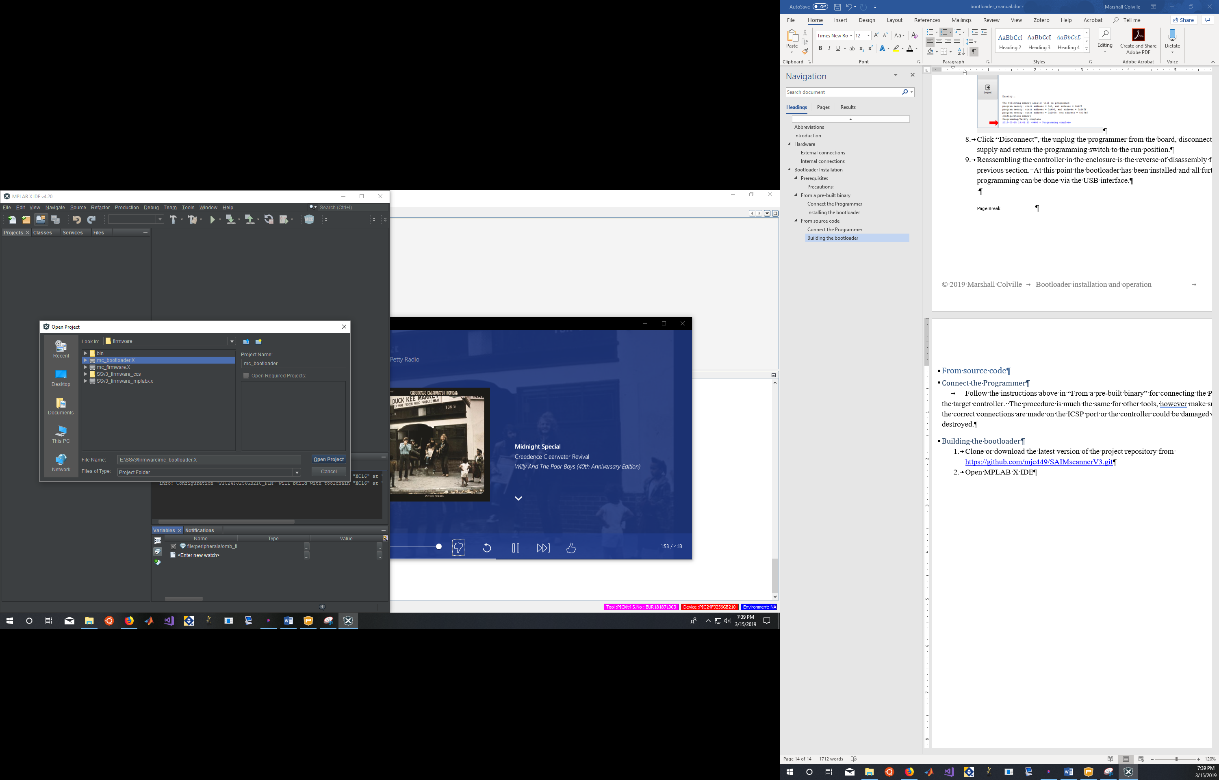

1. Select “File > Project Properties – mc_bootloader” from the menu. In the configuration window ensure that PIC24FJ256GB210 is selected for “Device”, XC16 for “Compiler Toolchain”, and PICkit 4 for “Hardware Tool”. If you are using a different programmer select it from the list, or if it is not available you will have to use the programmer’s own software to load the bootloader hex file to the controller.

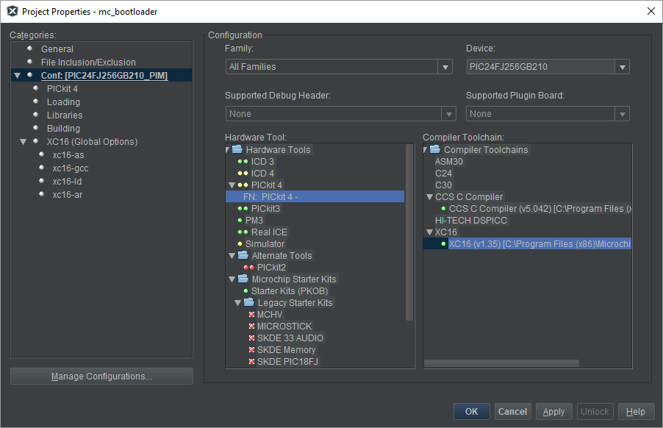

1. In the properties tree select PICkit4. In the dropdown at the top select “Memories to Program” and ensure that “Allow PICkit 4 to Select Memories” is selected.

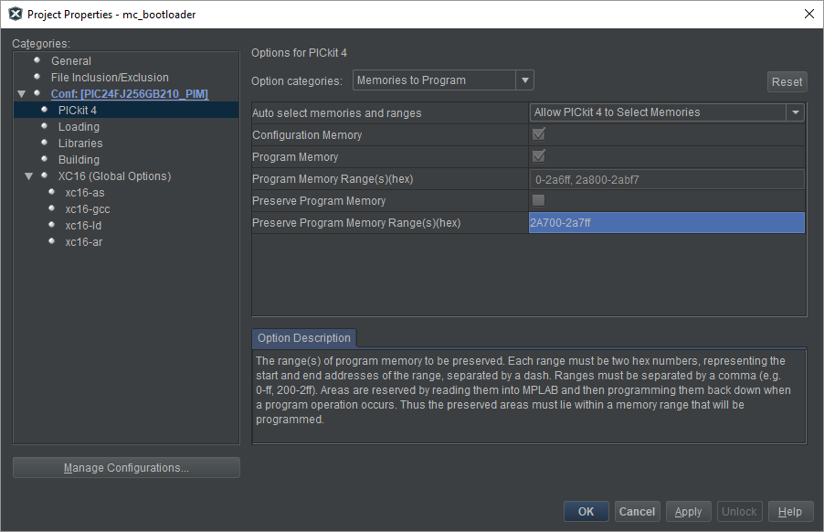

1. Choose “Power” from the dropdown at the top of the PICkit 4 properties window and ensure that “Power target circuit from PICkit 4” is unchecked.

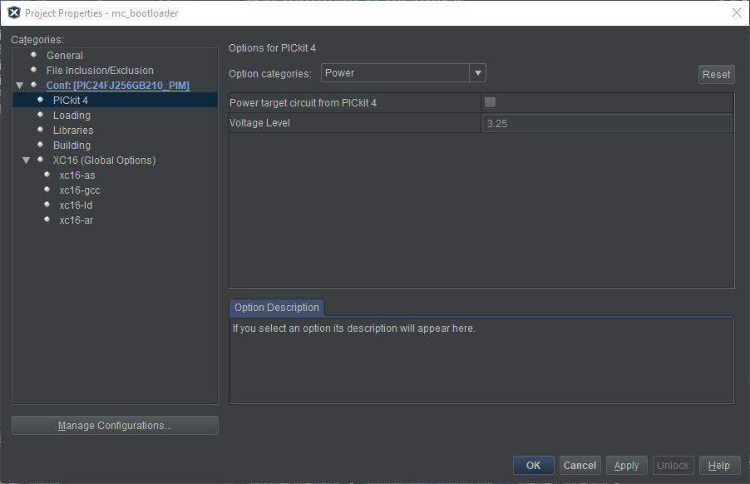

1. Select select xc16-gcc from the properties tree. Select “Optimizations” from the dropdown menu at the top of the page. Ensure that the optimization level is set to “s”. Click “OK” to close the options window.

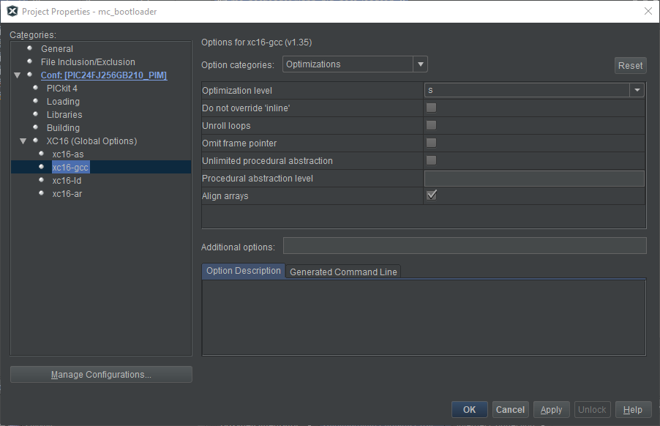

1. To build the project only without concurrently programming the device, select “Production > Build Project” from the menu or from the toolbar click on the hammer icon to build the project. The output window will display the build info. The output should end with the lines “BUILD SUCCESSFUL (total time: XX); Loading code from …; Loading completed”.

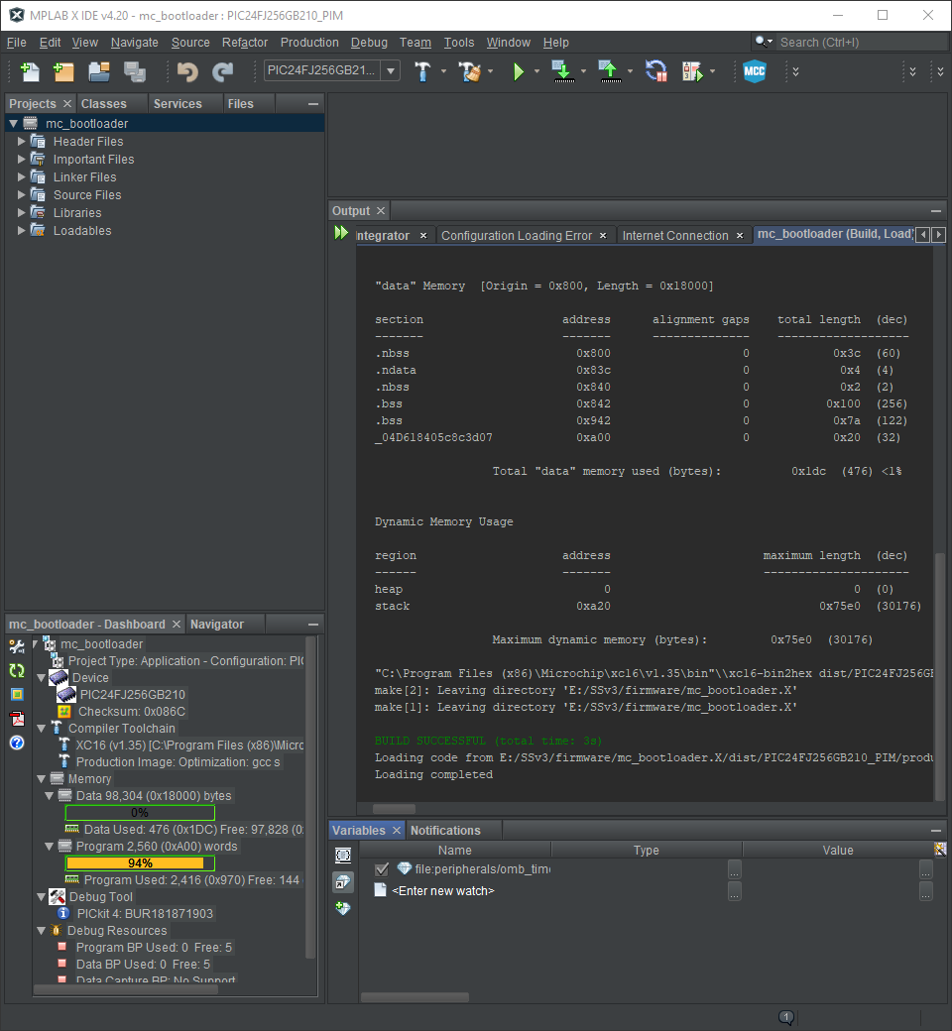

1. To build and program the controller in a single step make sure that the PICkit 4 is connected to the controller. Place the controller in program mode with the switch on the PCB. Connect the power supply to the controller, and ensure that the red LED next to the ICSP port is on. In MPLAB click the “Make and Program Device” button (green arrow pointing toward chip icon) on the toolbar. The build output should look similar to that below. A second output tab will open for the programmer. Check that the output ends with “Programming/Verify complete”.

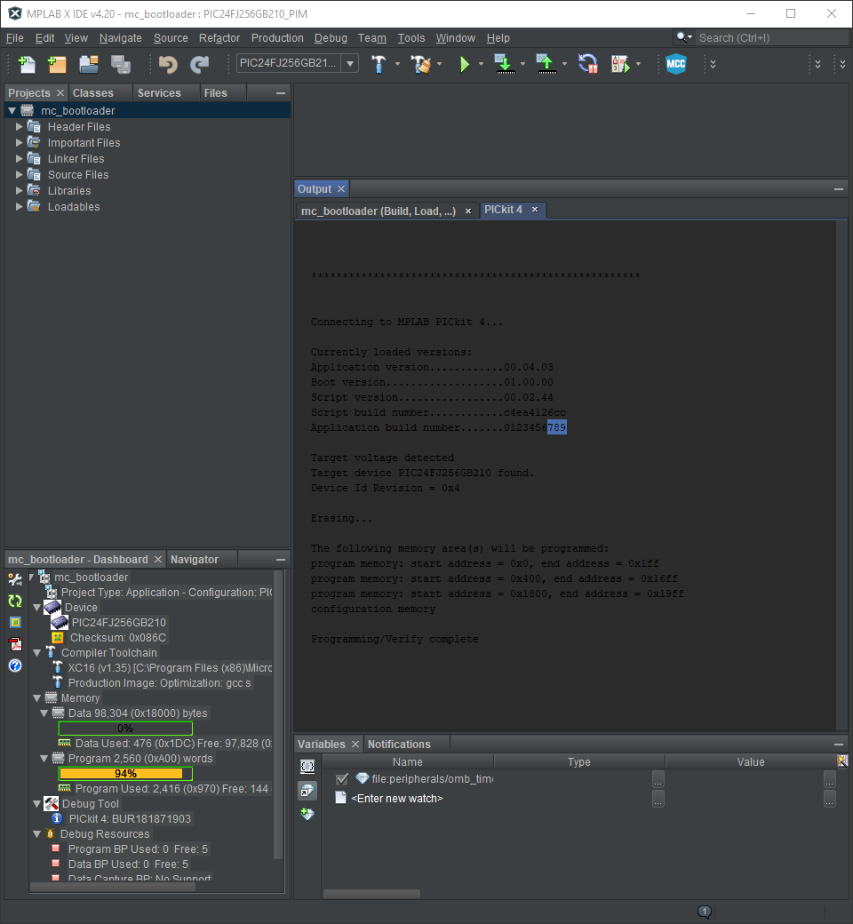

1. Disconnect the power supply and programmer from the controller. Move the programming switch back to run mode and replace any jumpers (if present) on the ICSP pins. Reassemble the controller.

# **Bootloader operation**

## Host software

The bootloader firmware is a modified version of Microchip’s USB HID bootloader firmware provided in the Microchip Libraries for Applications (MLA). For this reason the easiest way to program the micro-controller unit is using the host program included in the MLA.

The MLA is available at: <https://www.microchip.com/mplab/microchip-libraries-for-applications>

Install the MLA according to the prompts. The only component needed for this project is the USB Demo Projects, and the others can be skipped to save disc space. To do this, at the “Select Components” step uncheck everything except “USB Demo Projects” then click “Next”. Continue through to complete the installation.

Once the installation has finished navigate to the bootloader folder. If you opted for the default path this will be: C:\microchip\mla\<version>\apps\usb\device\bootloaders\. The host-side software can be found in: bootloaders\utilities\bin\<platform>\HIDBootloader.exe.

Double click the HIDBootloader.exe icon to launch the host software.

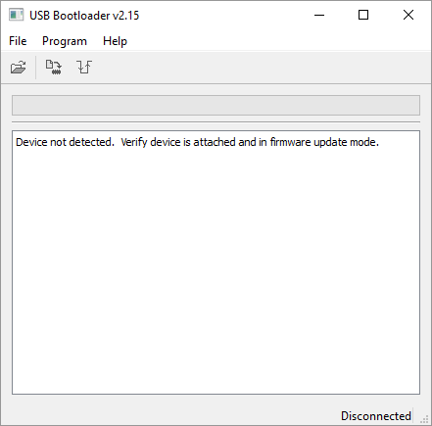

## Placing the micro-controller unit into bootloader mode

There are 3 means of entering bootloader mode on the device:

1. Through the application firmware by setting a flag in flash memory and restarting the device.
2. Through hardware. This option requires disassembling the enclosure and should only be used as a last resort.
3. If the controller detects application code corruption or if the application code reset is blank. These mechanisms are not accessible to the user.

### Firmware method

The final instruction in application memory (address 0x2ABF6) is reserved for system flags. . On startup the address is read into data memory and compared to determine whether to enter the bootloader or proceed to application code. To enter the bootloader the 24th bit is set to 0. Once set the bit can only be cleared by issuing a reset command over USB. A hard reset, loss of power, or a reset trap will not clear the flag.

The following block of code will set the goto bootloader flag:

